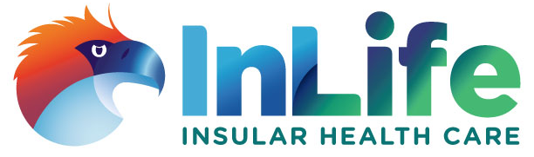
InLife Health Care, Inc.
2/F Insular Health Care Building, 167 Dela Rosa corner Legazpi Streets, Legazpi Village, Makati City 1229 Metro Manila, Philippines
Telephone No. (632) 813-0131
Fax No. (632) 893-5953
Website: http://www.insularhealthcare.com.ph

GUIDELINES ON FILING OF CLAIMS

Claims for reimbursement will be governed by the following guidelines:

VALIDITY PERIOD:

- A claim for reimbursement must be filed and received by Insular Health Care within sixty (60) days from the date of availment for out-patient benefits and sixty (60) days from the date of discharge in case of in-patient benefits.

- Processing period shall be thirty (30) days from the date of receipt by Insular Health Care of the said claim provided that the member has submitted (together within the claim) all the necessary documents required. In case an additional requirement is needed, the 30-day period shall be reckoned against the date when said additional requirement is submitted.

REQUIREMENTS:
All claims for reimbursement must be submitted together with the original copy of the following documents:

- OUT-PATIENT
Medical Certificate from the attending physician
Clinical Abstract/Clinical History
Official Receipts of payments to physician and/or hospital
Charge slips with breakdown of charges

- IN-PATIENT
Medical Certificate from the attending physician
Clinical Abstract/Clinical History
Official Receipts of payments to physician and/or hospital
Statement of Account

Charge Slips with breakdown of charges
Operative Record/Surgical Procedure including histopathological report when applicable
Police Report and/or Subrogation Report if Medico-legal case

- PRESCRIPTION MEDICINE BENEFIT / DENTAL BENEFIT
Medical Certificate from the attending physician/dentist
Prescription
Official Receipts indicating medicines purchased

It is understood that other requirements may be imposed as deemed necessary.
For Inquiries and follow-up, you may call the Medical Claims Section at Tel. No. (632) 813-0131 local 8301-8302.


CLAIM FOR REIMBURSEMENT FORM
- Claimant’s General Data
Name: | I.D. No.:
Address: | Age/Sex:
Tel. No.: | Inclusive Date of Availment:
Plan Type: | Hospital Availed at:
Payee/Cheque payable to:

- Nature of Claim
 | In-Patient |  | Prescription Benefit
 | Out-Patient |  | Dental Benefit
 | Others: (please specify)________________________________________________________________________________

- Please cite reason(s) for reimbursement (You may use a separate sheet if necessary which must be signed and dated by the claimant):________________________________________________________________________________________________

- Declaration
I, the undersigned, declare that all the foregoing information are true, and that I have submitted all the required documents relevant to this claim, and the amount claimed herein are lawfully due to me under the terms, conditions and exceptions of my health care Agreement.

Amount in Words |  | Amount in Figures
Signature over Printed Name |  | Date

